Light Following Mouse Robot (by Joshua Supratman)

Purpose of this tutorial is to create a simple robot with adjustable circuit to create different effects

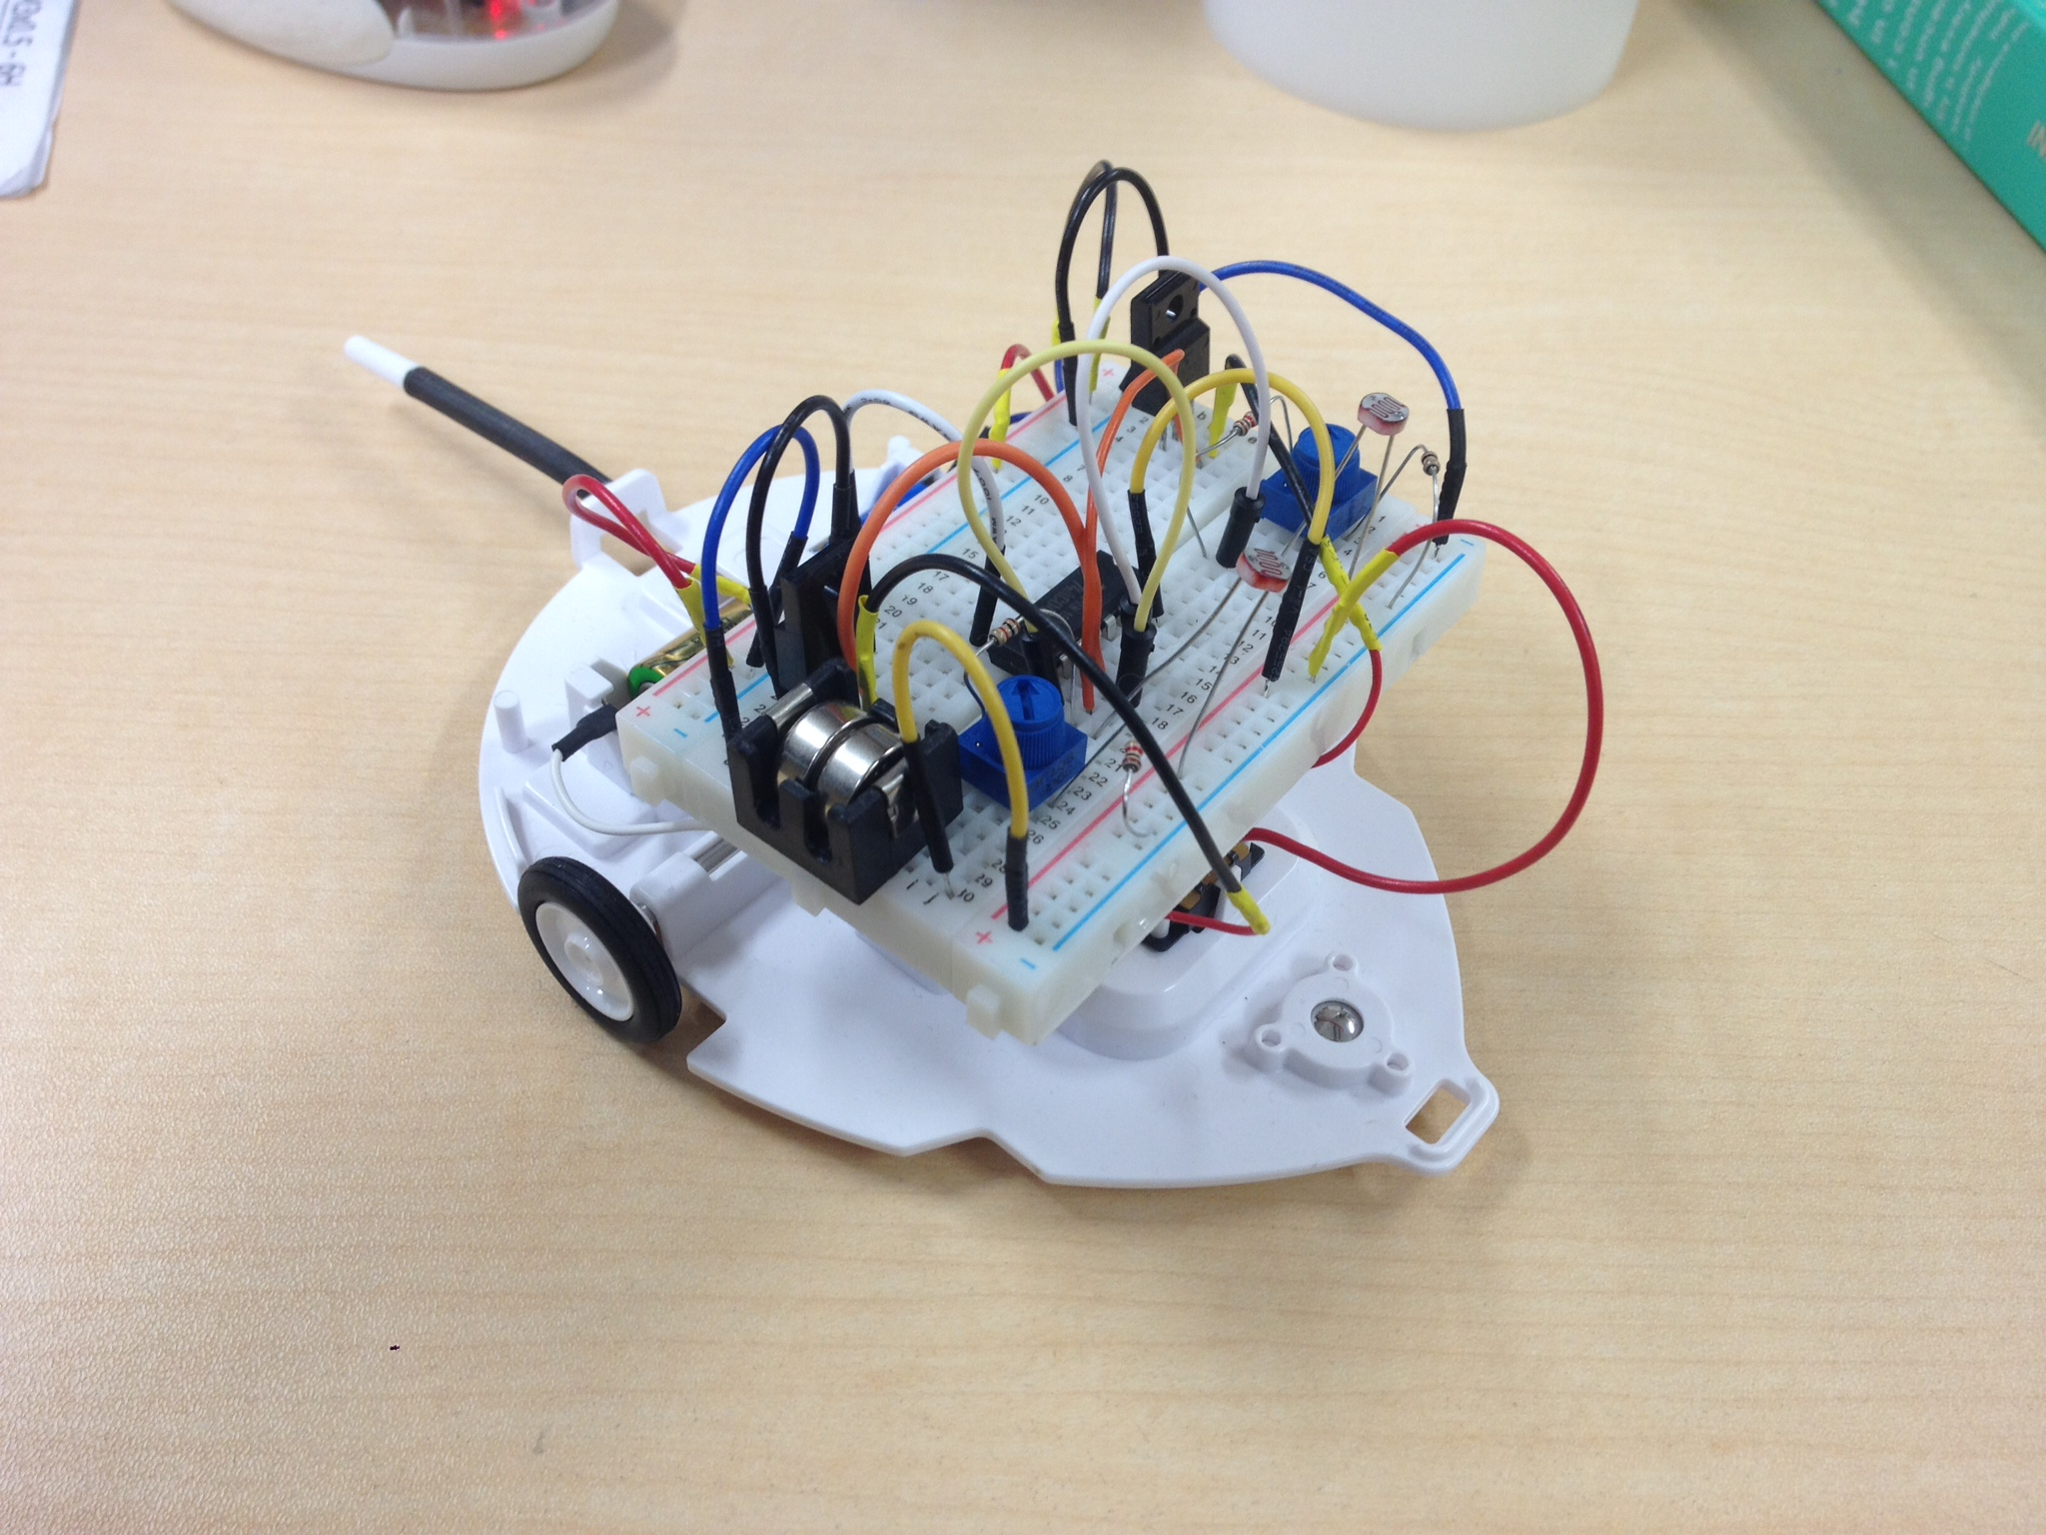

Materials

* N-ch FET K2232 x2

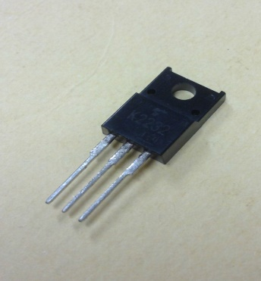

* Resistor 1kΩ x 4

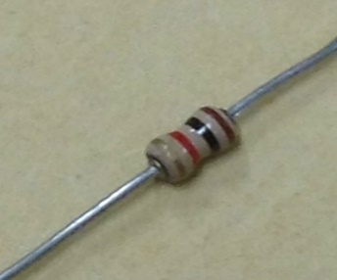

* Variable Resistor 10 kΩx2

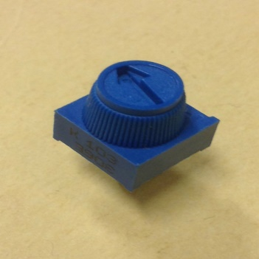

* Cds cell 5mm 0.5MΩx2

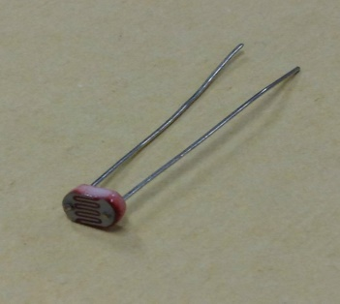

* Bread board

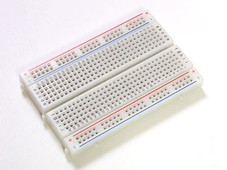

* Coin battery LR44 x2

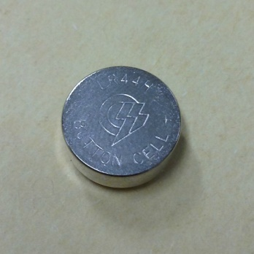

* Coin battery holder MPD BH1/3N-C CR1 3N用(LR44 2個)電池ボックス

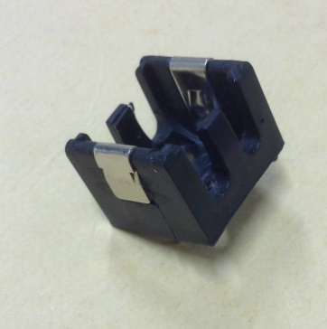

* Insulator tape

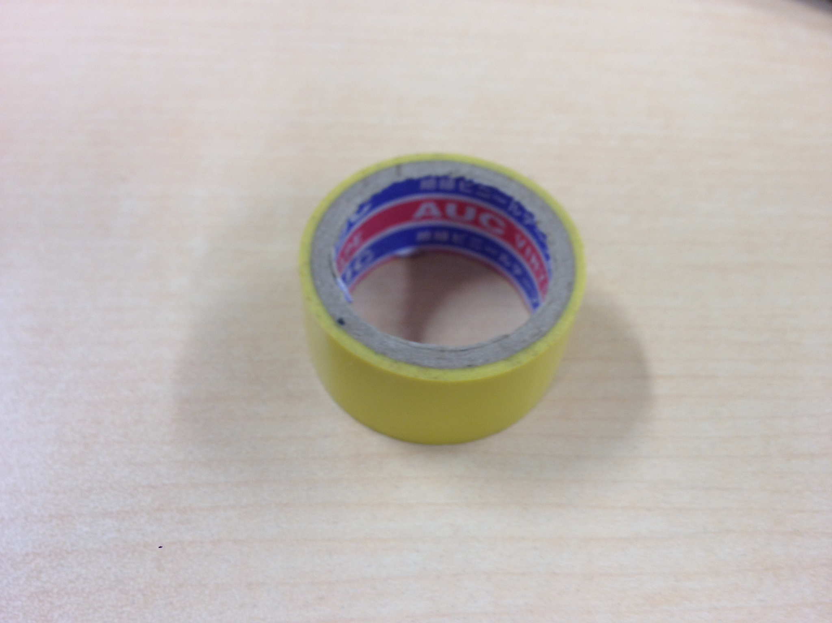

* Wire Stripper

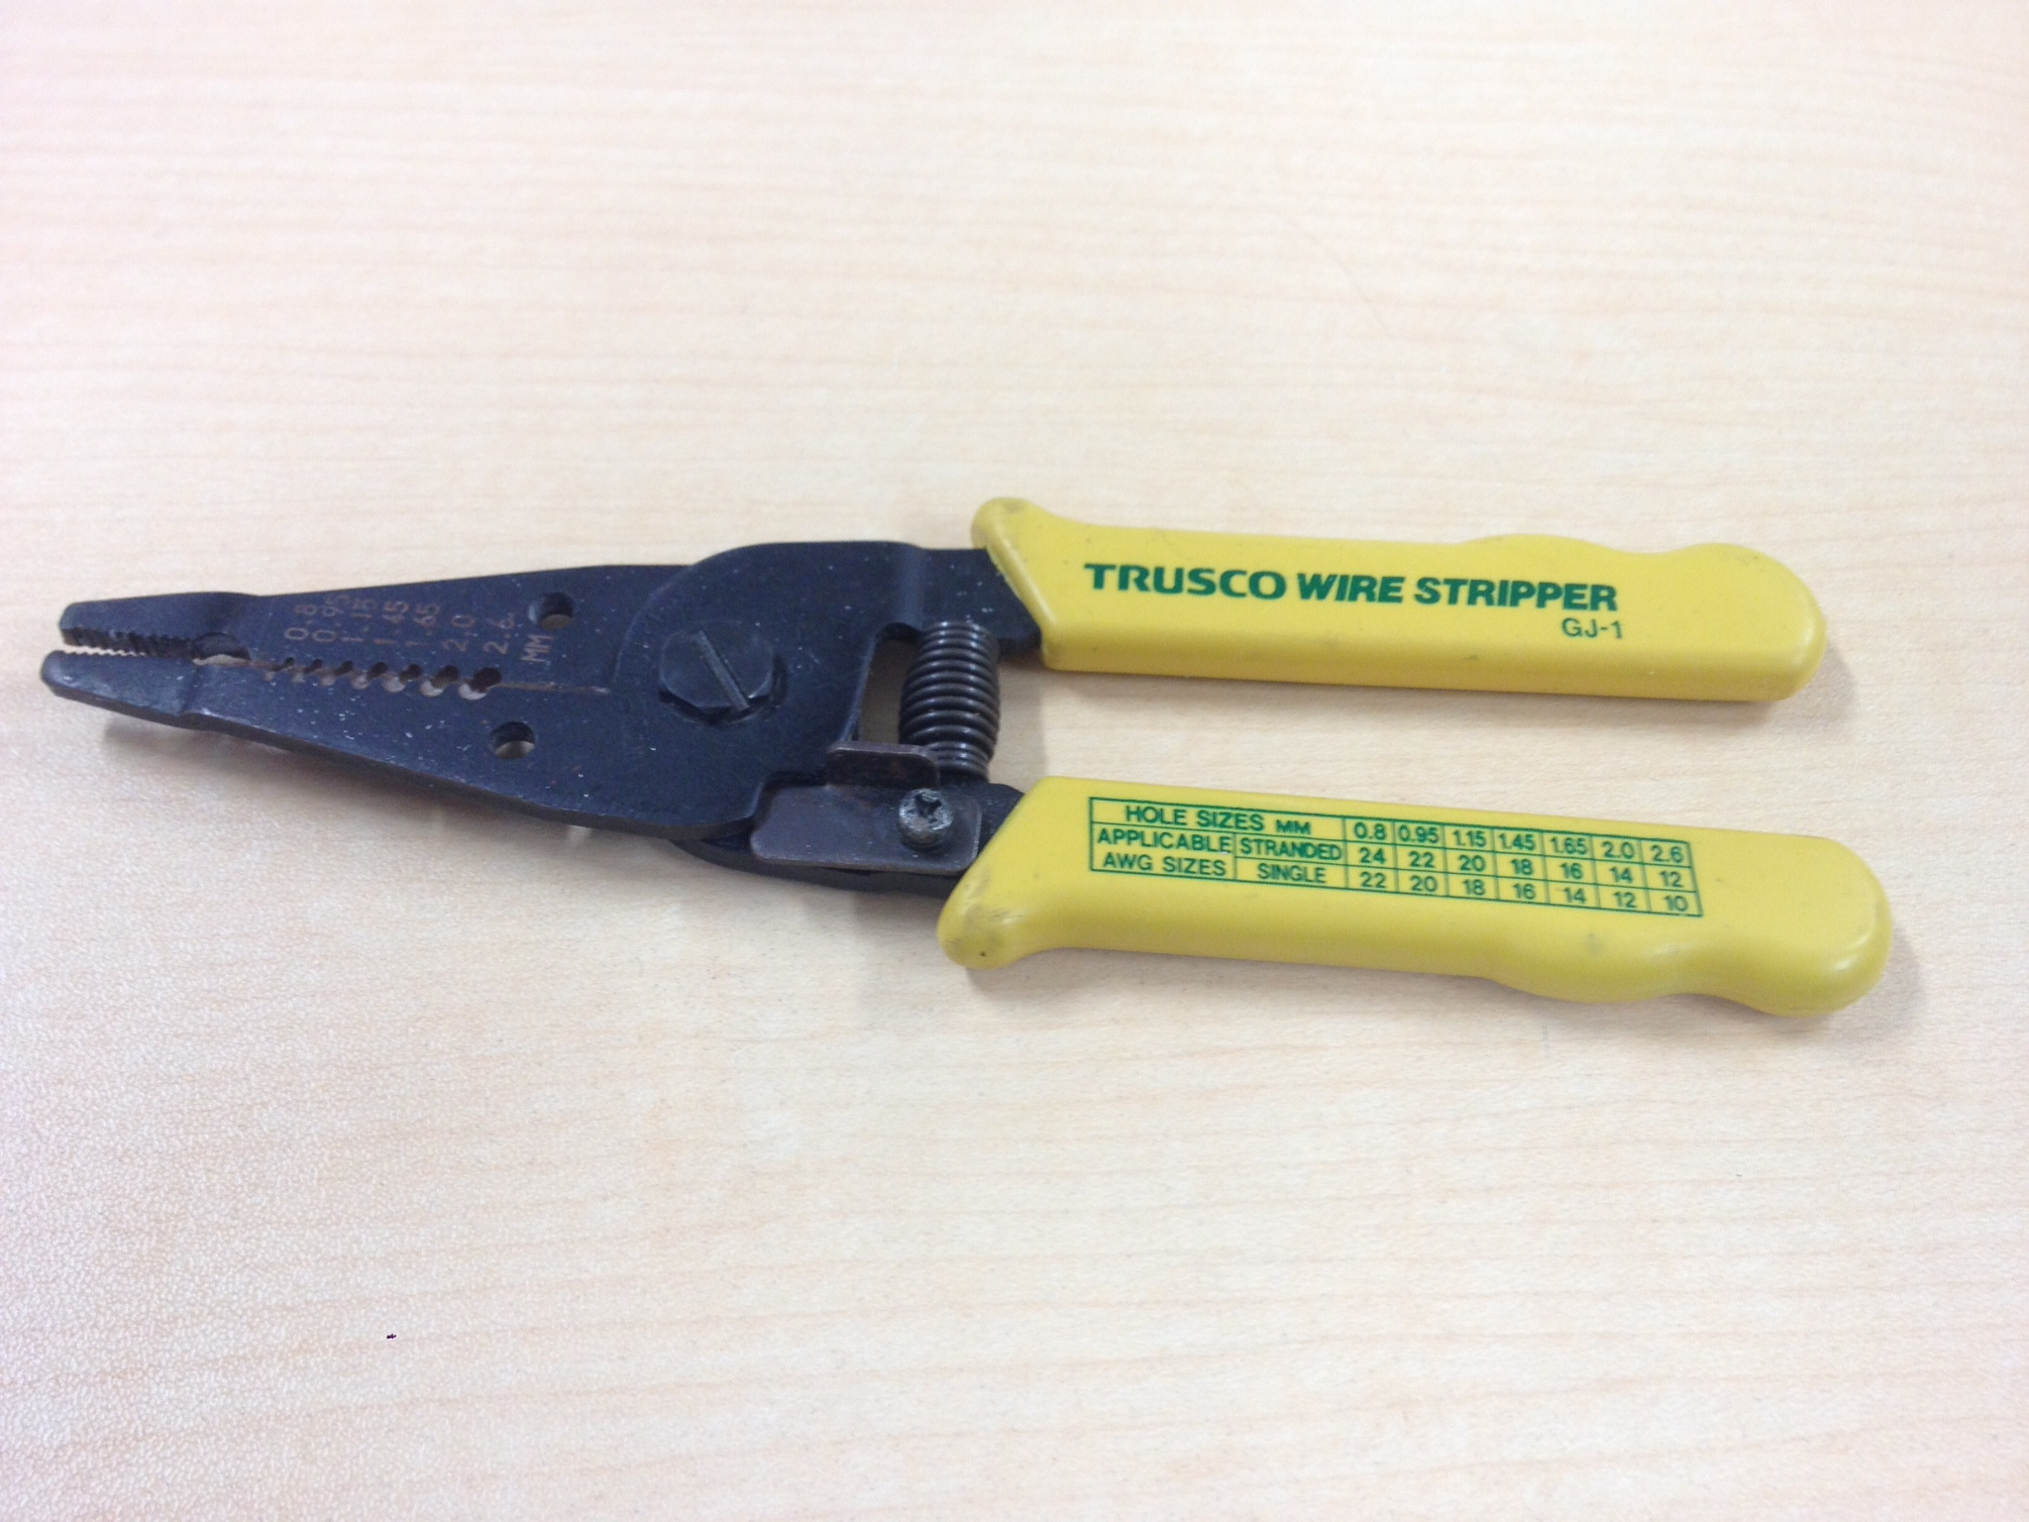

* Nipper

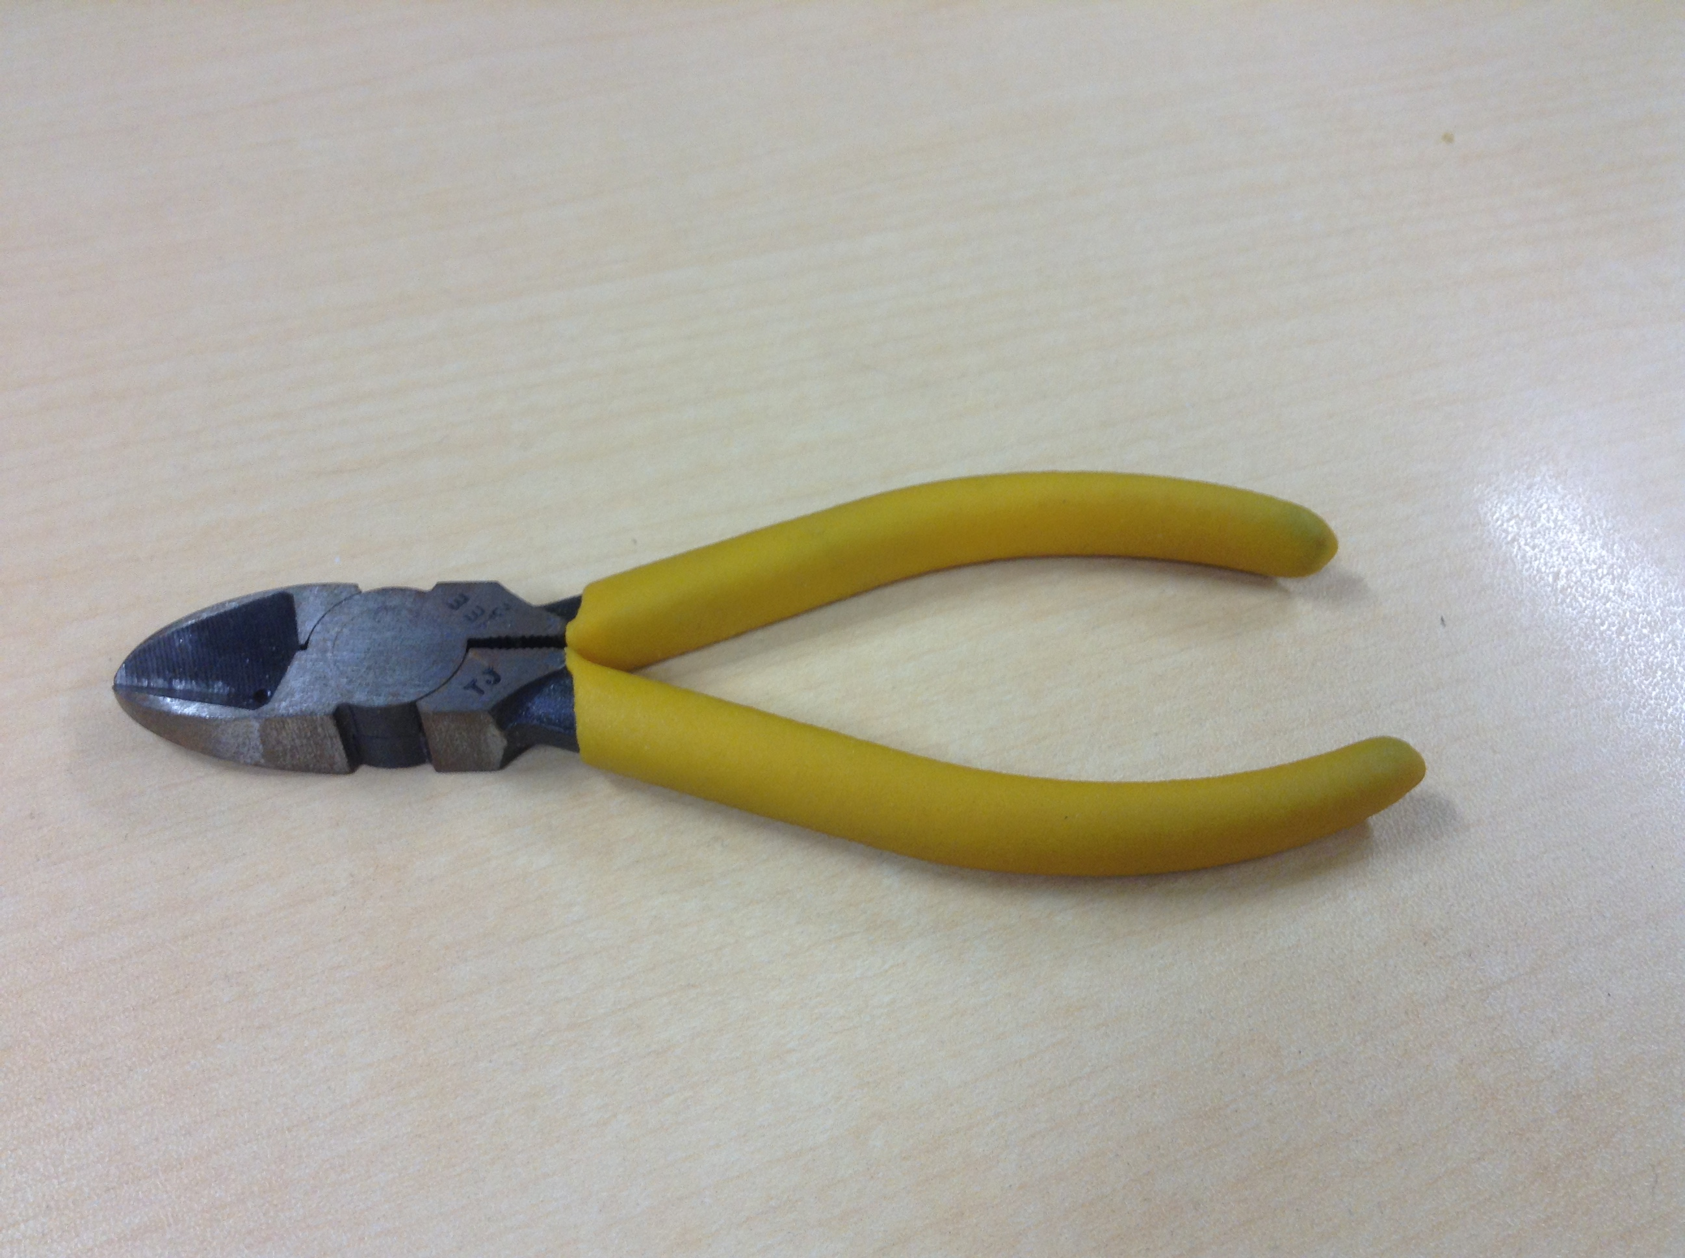

* Wires

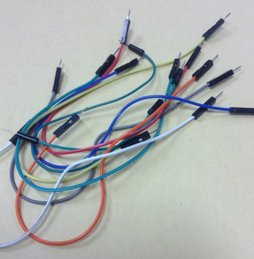

* Tamiya’s Mouse Robot

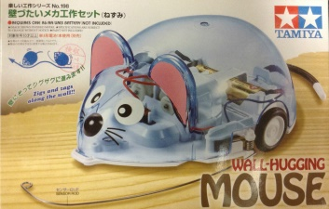

* (optional) Inverter IC

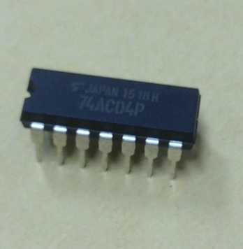

* (optional) AND logic IC

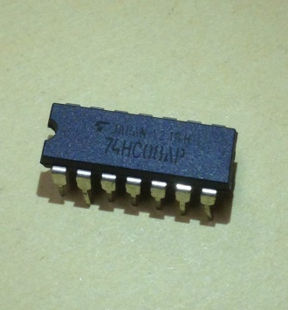

* (optional) flash light

How to make jumper wire

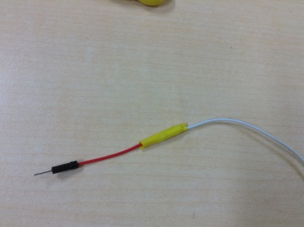

1. Use the nipper to cut the desired wire and the jumper wire

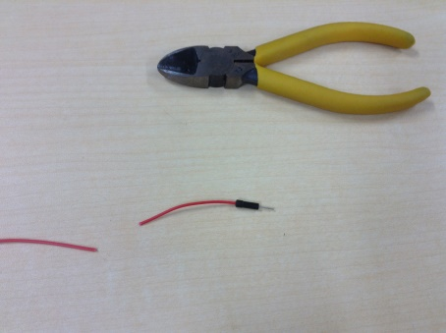

1. Use the wire stripper to strip at least 1 cm of wire

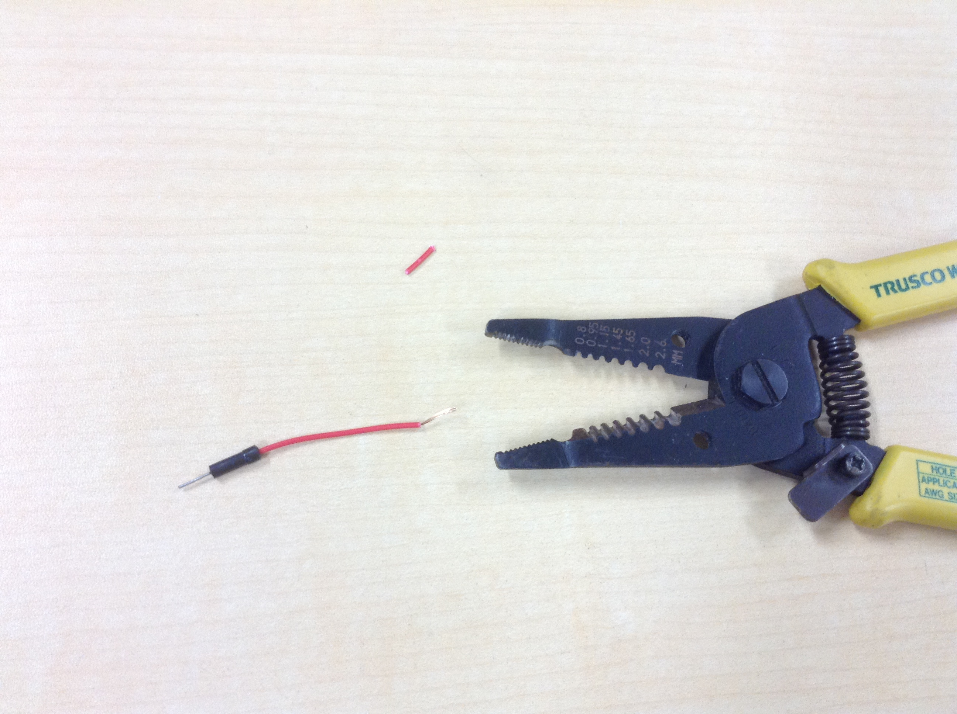

1. Make small hooks as shown below

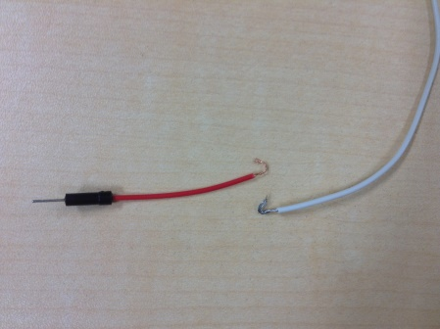

1. Bind the wires together and cover it using vinyl tape

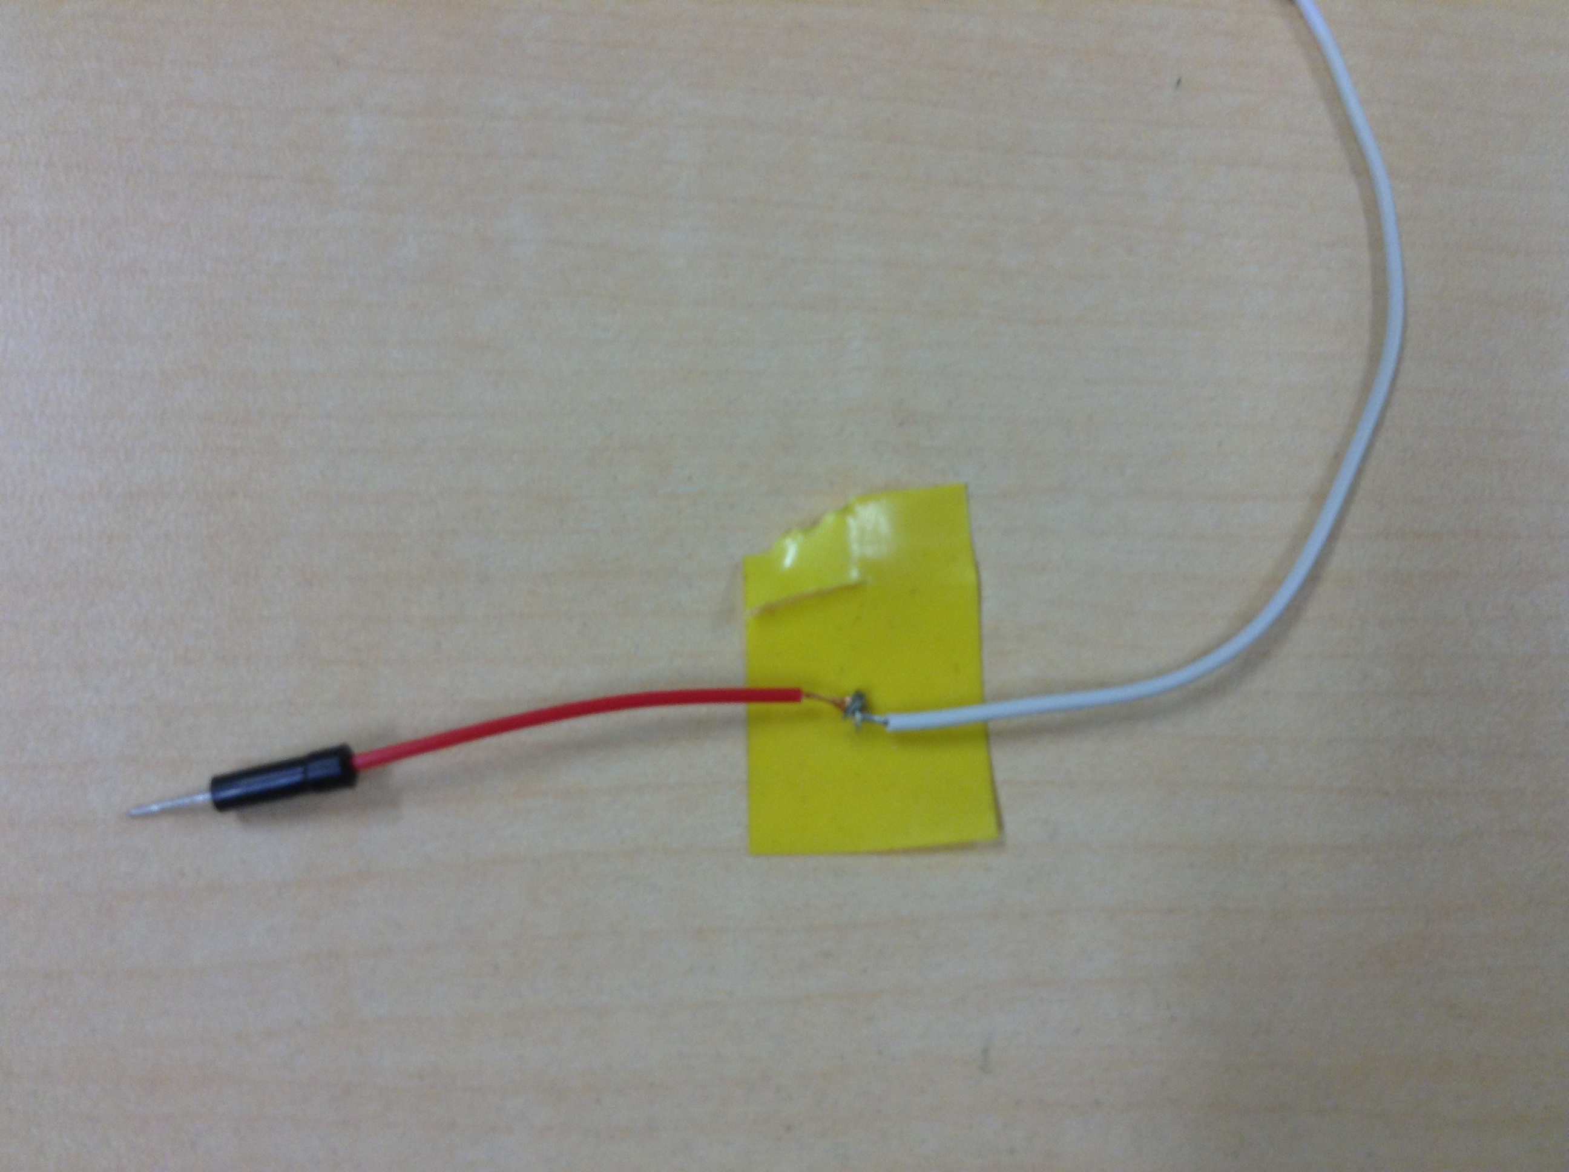

How to make

1. Follow Tamiya’s Mouse Robot instruction and make the robot

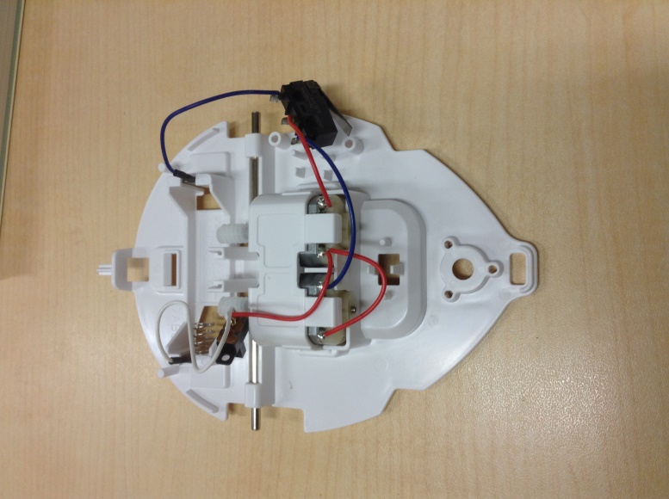

1. Remove the switch and cut unnecessary wires

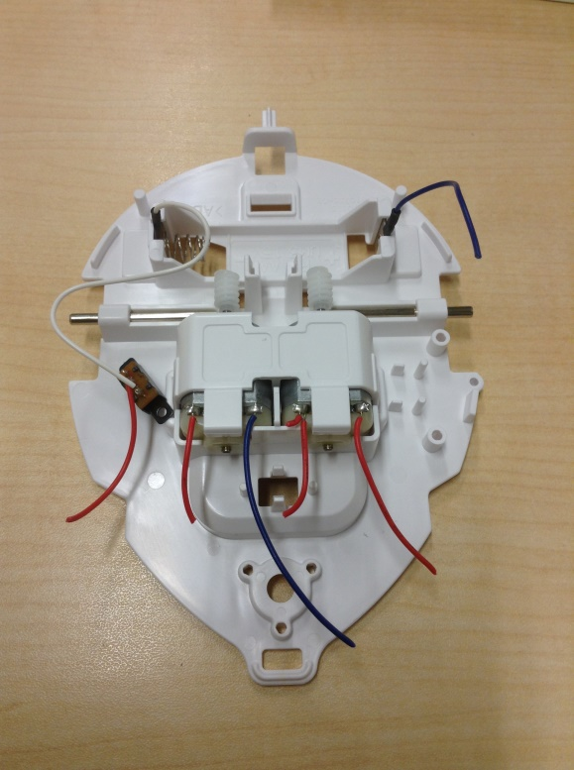

1. Make jumper wires for motor and battery wires and place the motor’s jumper wires over the gearbox toward the battery

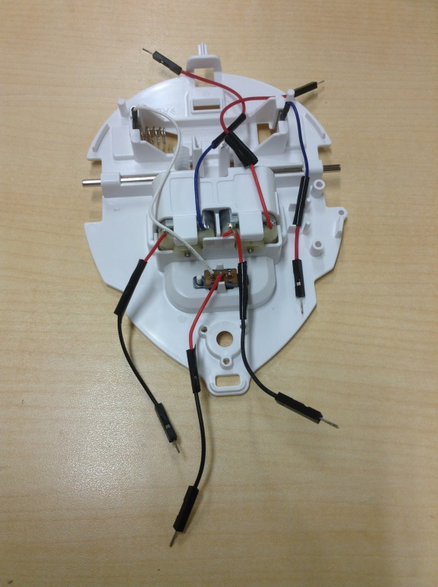

1. Place the bread board on top of the gearbox

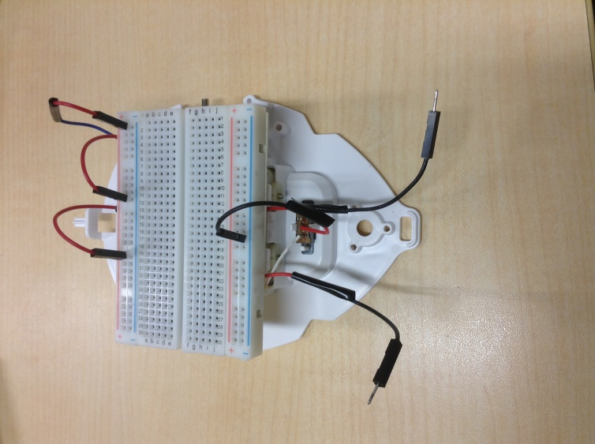

1. Design the circuit

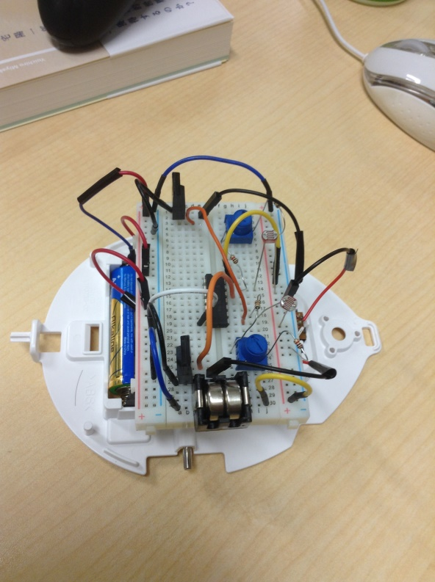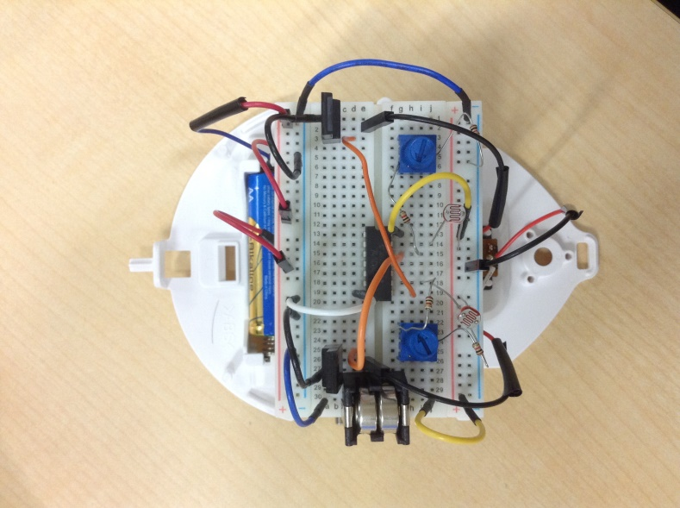

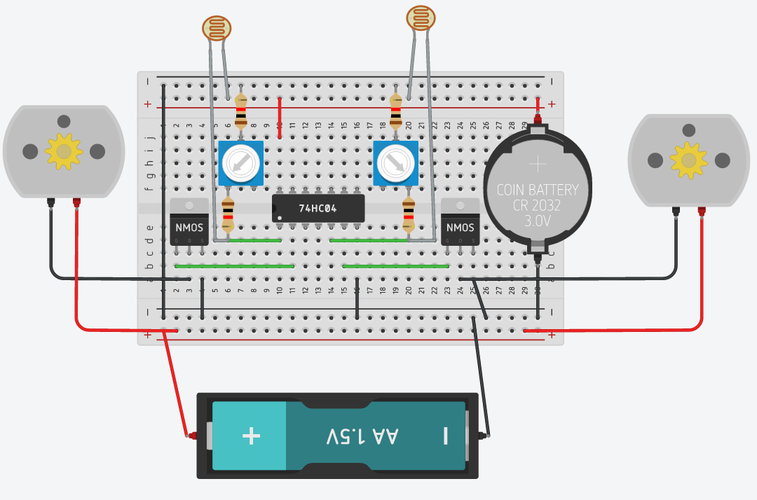

How to use

1. Rotate the variable resistor until the motor stop moving
2. Rotate the variable resistor and find the value just before the motor start moving
3. Use external light source or your hand and cover the cds cell to control the robot
4. Redesign circuit for your own use (refer to /circuit)

Circuit Variation:

Pull Up Resistor

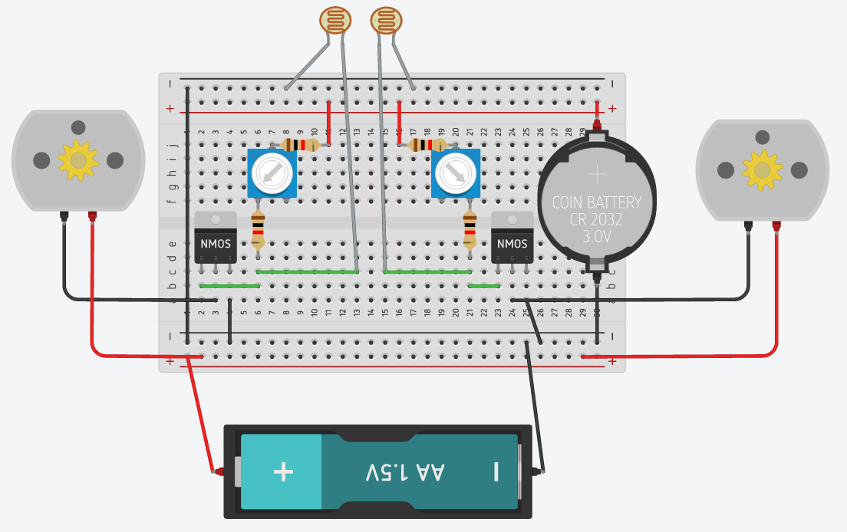

Pull Down Resistor

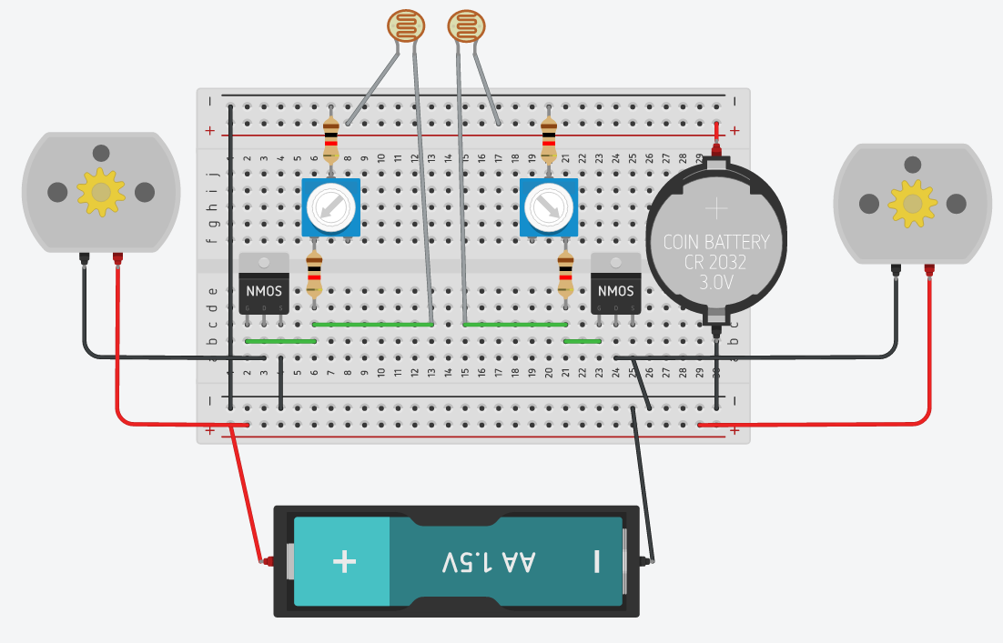

AND with Pull Up Resistor

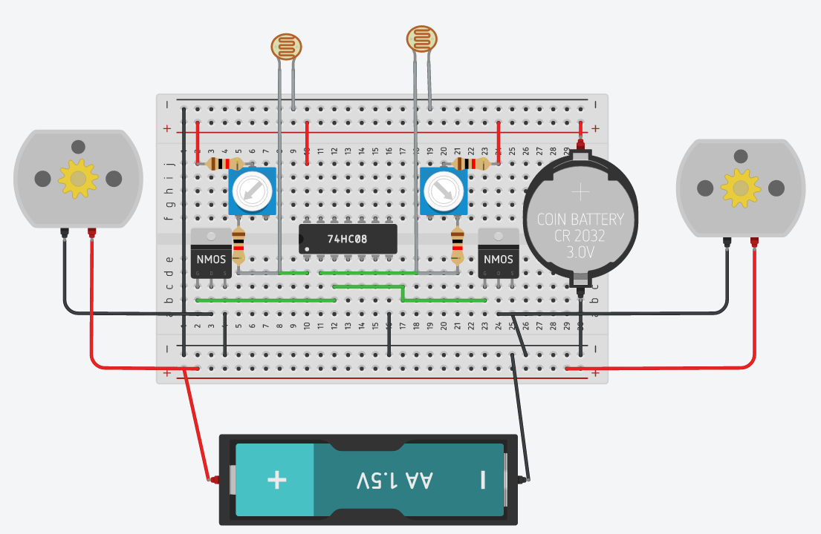

AND with Pull Down Resistor

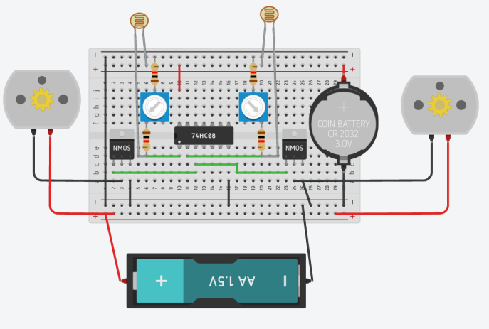

NOT with Pull Up Resistor

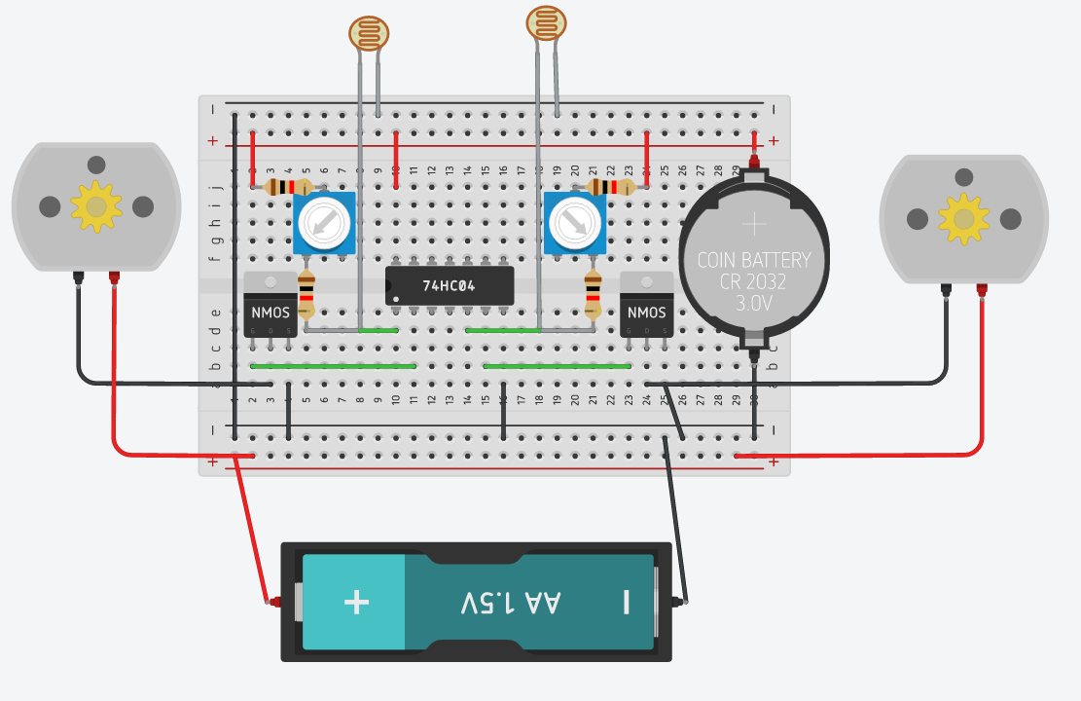

NOT with Pull Down Resistor

